**Project Development Phase**

**Sprint – 1 Report**

|  |  |
| --- | --- |
| Team ID | PNT2022TMID05962 |
| Project Name | **Personal Expense Tracker Application** |

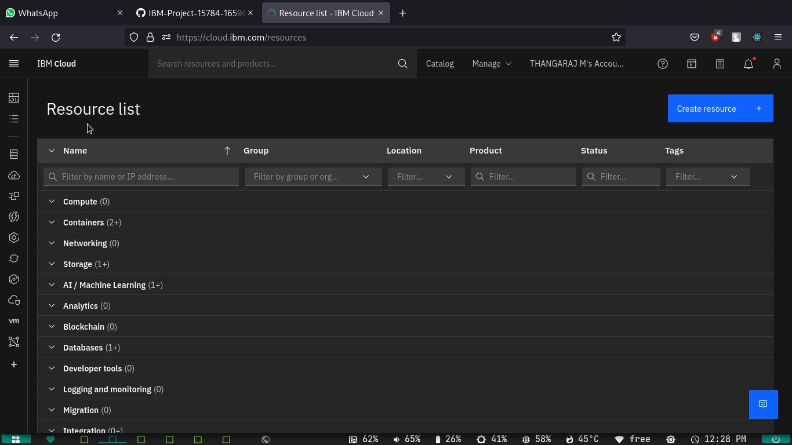**1. Flask – done installation and Started working**

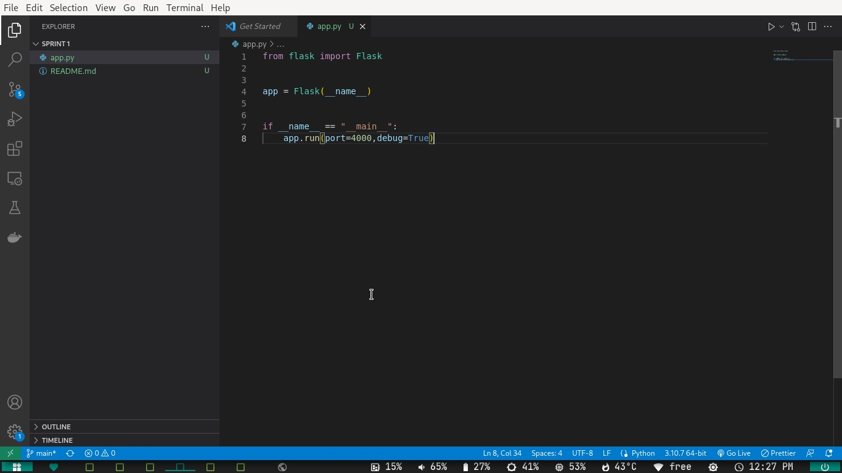

**IBMcloud – done**

**Account created**

**Cli installed**

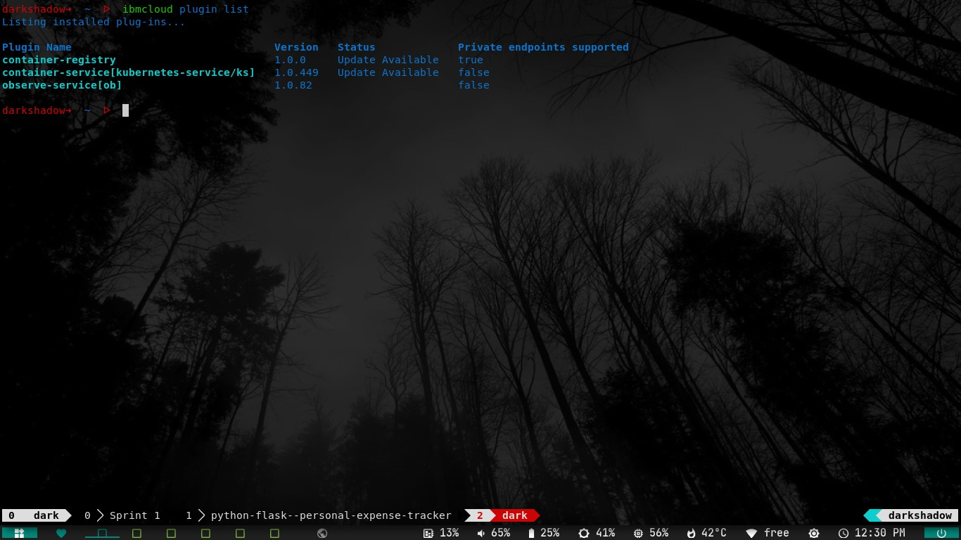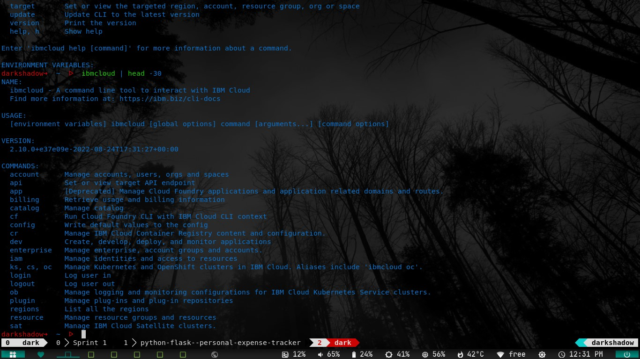

**Docker Installed**

